**1) Which of the following is an example of time series problem?**

**1. Estimating number of hotel rooms booking in next 6 months.**  
**2. Estimating the total sales in next 3 years of an insurance company.**  
**3. Estimating the number of calls for the next one week.**

A) Only 3  
B) 1 and 2  
C) 2 and 3  
D) 1 and 3  
E) 1,2 and 3

**2) Which of the following is not an example of a time series model?**

A) Naive approach  
B) Exponential smoothing  
C) Moving Average  
D) None of the above

**3) Which of the following can’t be a component for a time series plot?**

A) Seasonality  
B) Trend  
C) Cyclical  
D) Noise  
E) None of the above

**4) Which of the following is relatively easier to estimate in time series modeling?**

A) Seasonality  
B) Cyclical  
C) No difference between Seasonality and Cyclical

**5) The below time series plot contains both Cyclical and Seasonality component.**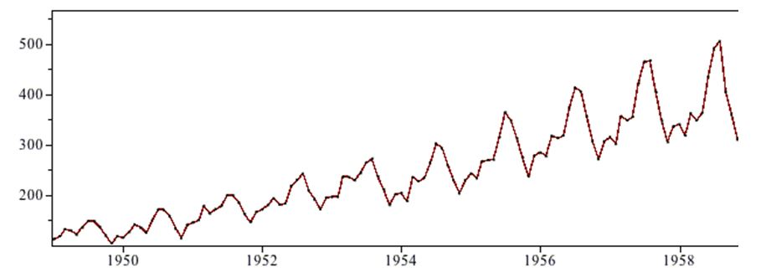  
A) TRUE  
B) FALSE

**6) Adjacent observations in time series data (excluding white noise) are independent and identically distributed (IID).**

A) TRUE  
B) FALSE

**7) Smoothing parameter close to one gives more weight or influence to recent observations over the forecast.**

A) TRUE  
B) FALSE

**8) Sum of weights in exponential smoothing is _____.**

A) <1  
B) 1  
C) >1  
D) None of the above

**9) What does autocovariance measure**?

A) Linear dependence between multiple points on the different series observed at different times  
B)Quadratic dependence between two points on the same series observed at different times  
C) Linear dependence between two points on different series observed at same time  
D) Linear dependence between two points on the same series observed at different times

**10) Which of the following is not a necessary condition for weakly stationary time series?**

A) Mean is constant and does not depend on time  
B) Autocovariance function depends on s and t only through their difference |s-t| (where t and s are moments in time)  
C) The time series under considerations is a finite variance process  
D) Time series is Gaussian

**11) Which of the following is not a technique used in smoothing time series?**

A) Nearest Neighbor Regression  
B) Locally weighted scatter plot smoothing  
C) Tree based models like (CART)  
D) Smoothing Splines

**12) Stationarity is a desirable property for a time series process.**

A) TRUE  
B) FALSE

**13) Imagine, you are working on a time series dataset. Your manager has asked you to build a highly accurate model. You started to build two types of models which are given below.**

**Model 1: Decision Tree model**

**Model 2: Time series regression model**

**At the end of evaluation of these two models, you found that model 2 is better than model 1. What could be the possible reason for your inference?**

A) Model 1 couldn’t map the linear relationship as good as Model 2  
B) Model 1 will always be better than Model 2  
C) You can’t compare decision tree with time series regression  
D) None of these

**14) Any stationary time series can be approximately the random superposition of sines and cosines oscillating at various frequencies.**

A) TRUE  
B) FALSE

**15) In autoregressive models _______?**

A) Current value of dependent variable is influenced by current values of independent variables  
B) Current value of dependent variable is influenced by current and past values of independent variables  
C) Current value of dependent variable is influenced by past values of both dependent and independent variables  
D) None of the above

**16) Which of the following is true for white noise?**

A) Mean =0  
B) Zero autocovariances  
C) Zero autocovariances except at lag zero  
D) Quadratic Variance

**17) For the following MA (3) process *yt* = *μ* + *Εt* + *θ*1*Εt*-1 + *θ*2*Εt*-2 + *θ*3*Εt*-3 , where *σt* is a zero mean white noise process with variance *σ*2**

A) ACF = 0 at lag 3  
B) ACF =0 at lag 5  
C) ACF =1 at lag 1  
D) ACF =0 at lag 2  
E) ACF = 0 at lag 3 and at lag 5

**18) Second differencing in time series can help to eliminate which trend?**

A) Quadratic Trend  
B) Linear Trend  
C) Both A & B  
D) None of the above

**19) Which of the following cross validation techniques is better suited for time series data?**

A)  k-Fold Cross Validation  
B) Leave-one-out Cross Validation  
C) Stratified Shuffle Split Cross Validation  
D) Forward Chaining Cross Validation

**20) In a time-series forecasting problem, if the seasonal indices for quarters 1, 2, and 3 are 0.80, 0.90, and 0.95 respectively. What can you say about the seasonal index of quarter 4?**

A) It will be less than 1  
B) It will be greater than 1  
C) It will be equal to 1  
D) Seasonality does not exist  
E) Data is insufficient